Final Workshop inputs

Cd Downloads

ssh –I "C:\Users\USER\Downloads\ilan-super-goated.pem" ubuntu@3.82.194.154

mkdir My_files

cd My_files

touch file1 file2

chmod a+x file1 file2

I pressed actions on my aws instance and click storage and then "Attach volume"

I added a gp3 5G volume to my instance

cd ..

lsblk

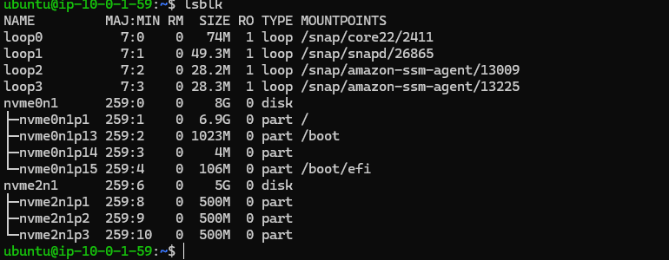

To create a partion
sudo fdisk /dev/nvme2n1

Later I pressed n
Enter
Enter
Enter
And for volume I typed +500M
A the end I pressed w to write the change

sudo partprobe

lsblk –f
sudo mkfs.xfs -f /dev/nvme2n1p1
sudo mkfs.xfs -f /dev/nvme2n1p2
mkdir directory1
mkdir directory2

sudo mount /dev/nvme2n1p2 /home/ubuntu/directory1
sudo mount /dev/nvme2n1p2 /home/ubuntu/directory2

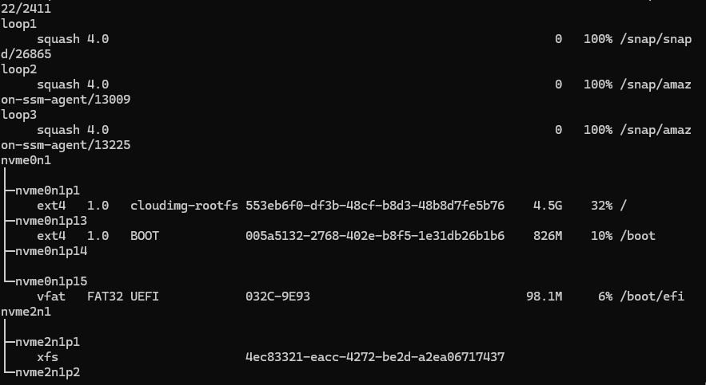

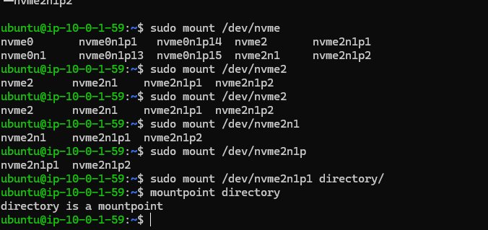

I have entered sudo nano /etc/fstab and added the UUID of the filesystem in order to make the kernel know to automatically store data from the dir to the partion I want.
